CSCI 321 Computer Science III Summer 2019

Lecture 3 Activity 1

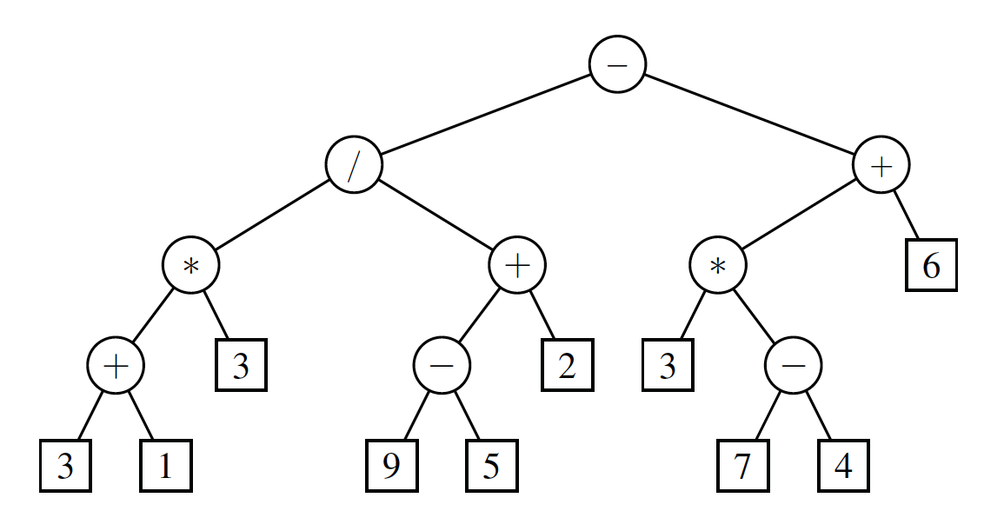

1. (50 points) In what order are positions visited during a ***preorder*** traversal of the tree in Fig 1. Hint: Draw the tree on a separate sheet of paper and then mark nodes as they are visited, writing down the output produced for each visit. Your output should be a sequence like this: “- / * …”.

- / * + 3 1 3 + - 9 5 2 + * - 7 4 3 6

1. (50 points) In what order are positions visited during a ***postorder*** traversal of the tree in Fig 1. Hint: Draw the tree on a separate sheet of paper and then mark nodes as they are visited, writing down the output produced for each visit. Your output should be a sequence like this: “3 1 + …”.

3 1 + 3 * 9 5 – 2 + / 7 4 – 3 * 6 + -